

**Containers & Docker Security LAB**

SUBMITTED TO SUBMITTED BY

Dr. Hitesh Kumar Sharma Siddharth Agarwal

500107594

R2142220663

Btech CSE DevOps B1

**EXPERIMENT 2**

**AIM: Working with Docker (Basic Commands)**

**Steps to Complete:**

1. Search a Redis image on DockerHub

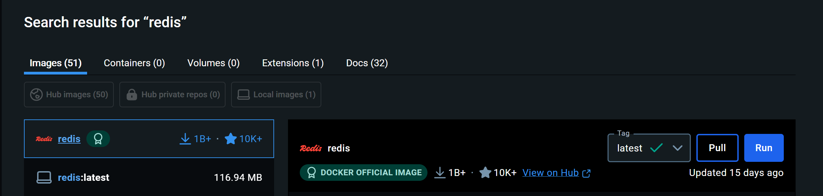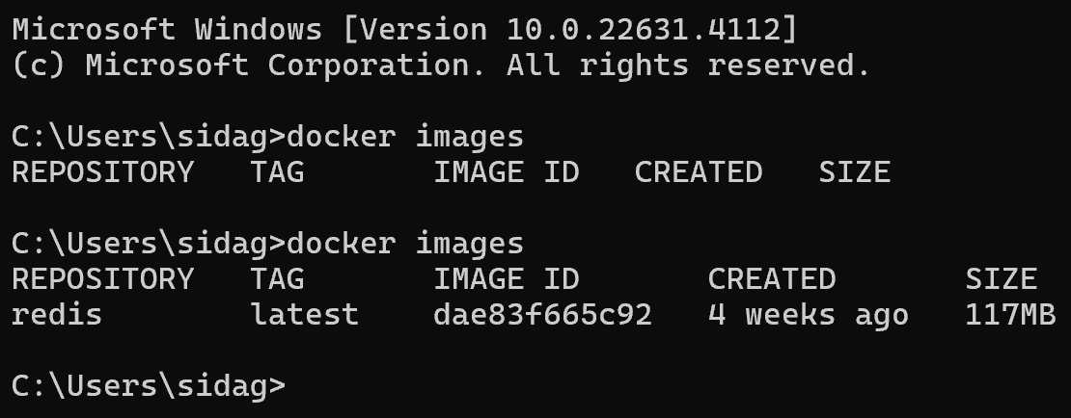

1. Run Docker Container of Redis Image in background

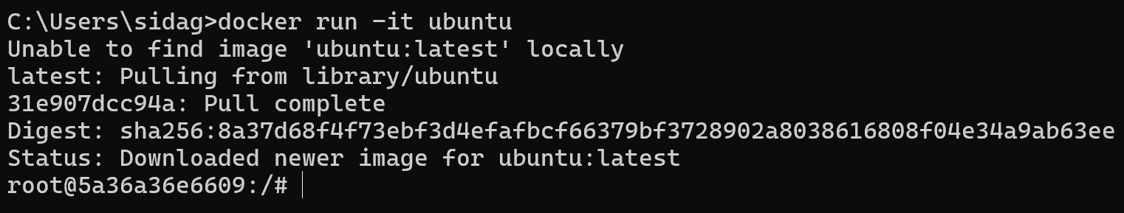

1. Run Docker PS and Docker PS –a

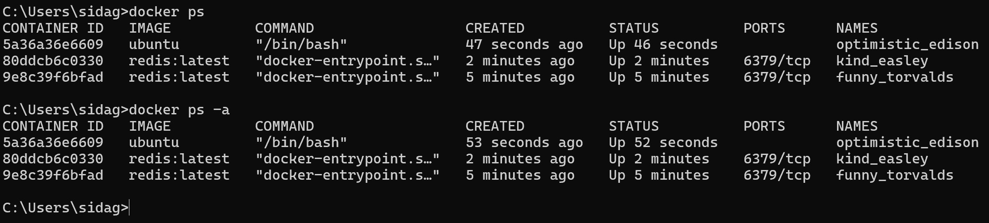

1. Run Docker Container and take its console

